**15 dic 2021**

**Exercise 1**

x variable

I(x) initial position of x left lower corner (1,1)

F(x) final position of x right top corner (8,8)

Need a formula to show how a system is evolving

T(x, x’) x old x’ new variable

I(x) ^ F(x) is consistent, 0 move are consistent

I(x0) ^ T(x0, x1) ^ F(x1) if it not consistent

I(x0) ^ T(x0, x1) ^ T(x1, x2)^ F(x2)

…

Until you get sat

Transition system,

Assert and retract

You might need 10 moves…

—————

|  |  |  |  |  |  |  |  |
| --- | --- | --- | --- | --- | --- | --- | --- |
|  |  |  |  |  |  |  |  |
|  |  |  |  | AA |  |  |  |
|  |  |  |  |  |  |  |  |
|  |  |  | KNIGHT |  |  |  |  |
|  |  |  |  |  |  |  |  |
|  |  |  |  |  |  |  |  |
|  |  |  |  |  |  |  |  |

Chess board

Knight can go here

Can go to AA

| y’-y | = 2

| x^ -x | = 1

Or

| y’-y | = 1

| x^ -x | = 2

So ( | y’-y | = 2 ^ | x^ -x | = 1) v ( | y’-y | = 1 | x^ -x | = 2) ^ 1 ≤ x’ ≤ 8 ^ 1 ≤ y’ ≤ 8 ^

Can’t go outside

Declare initial x=1 ^ y=1

Declare final x=8 ^ y=8

It is called **bounded model check**

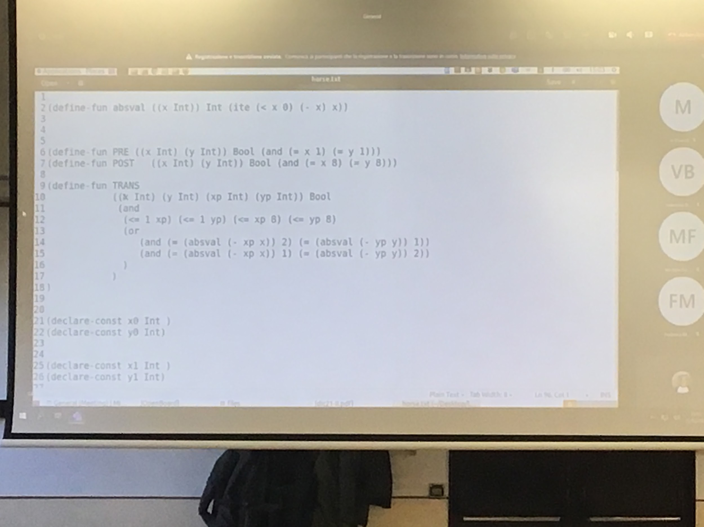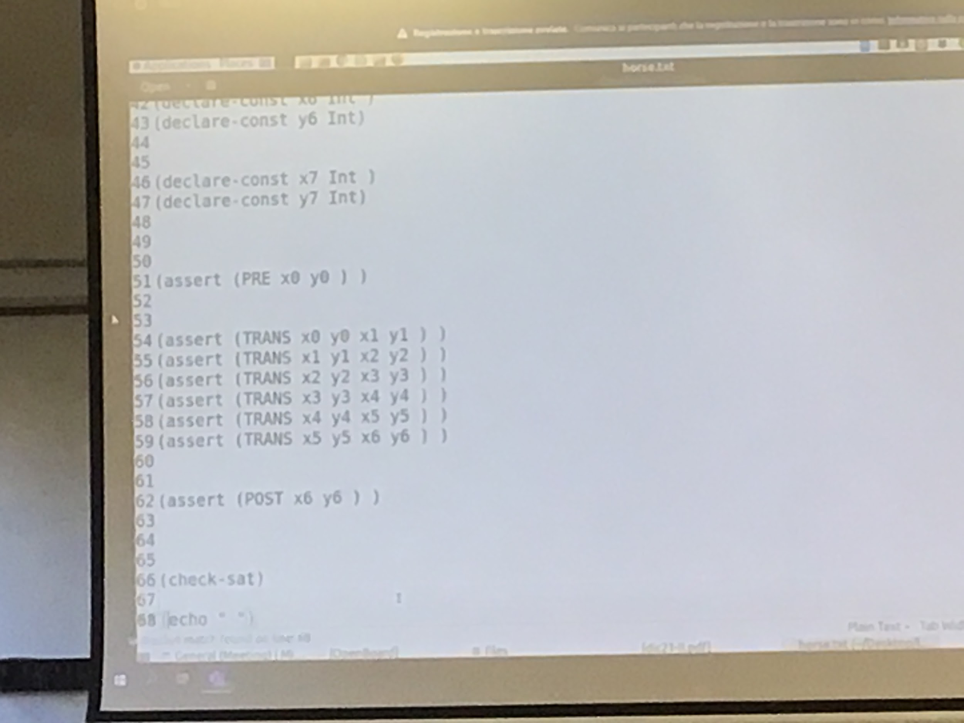

To see the moves

Get-val

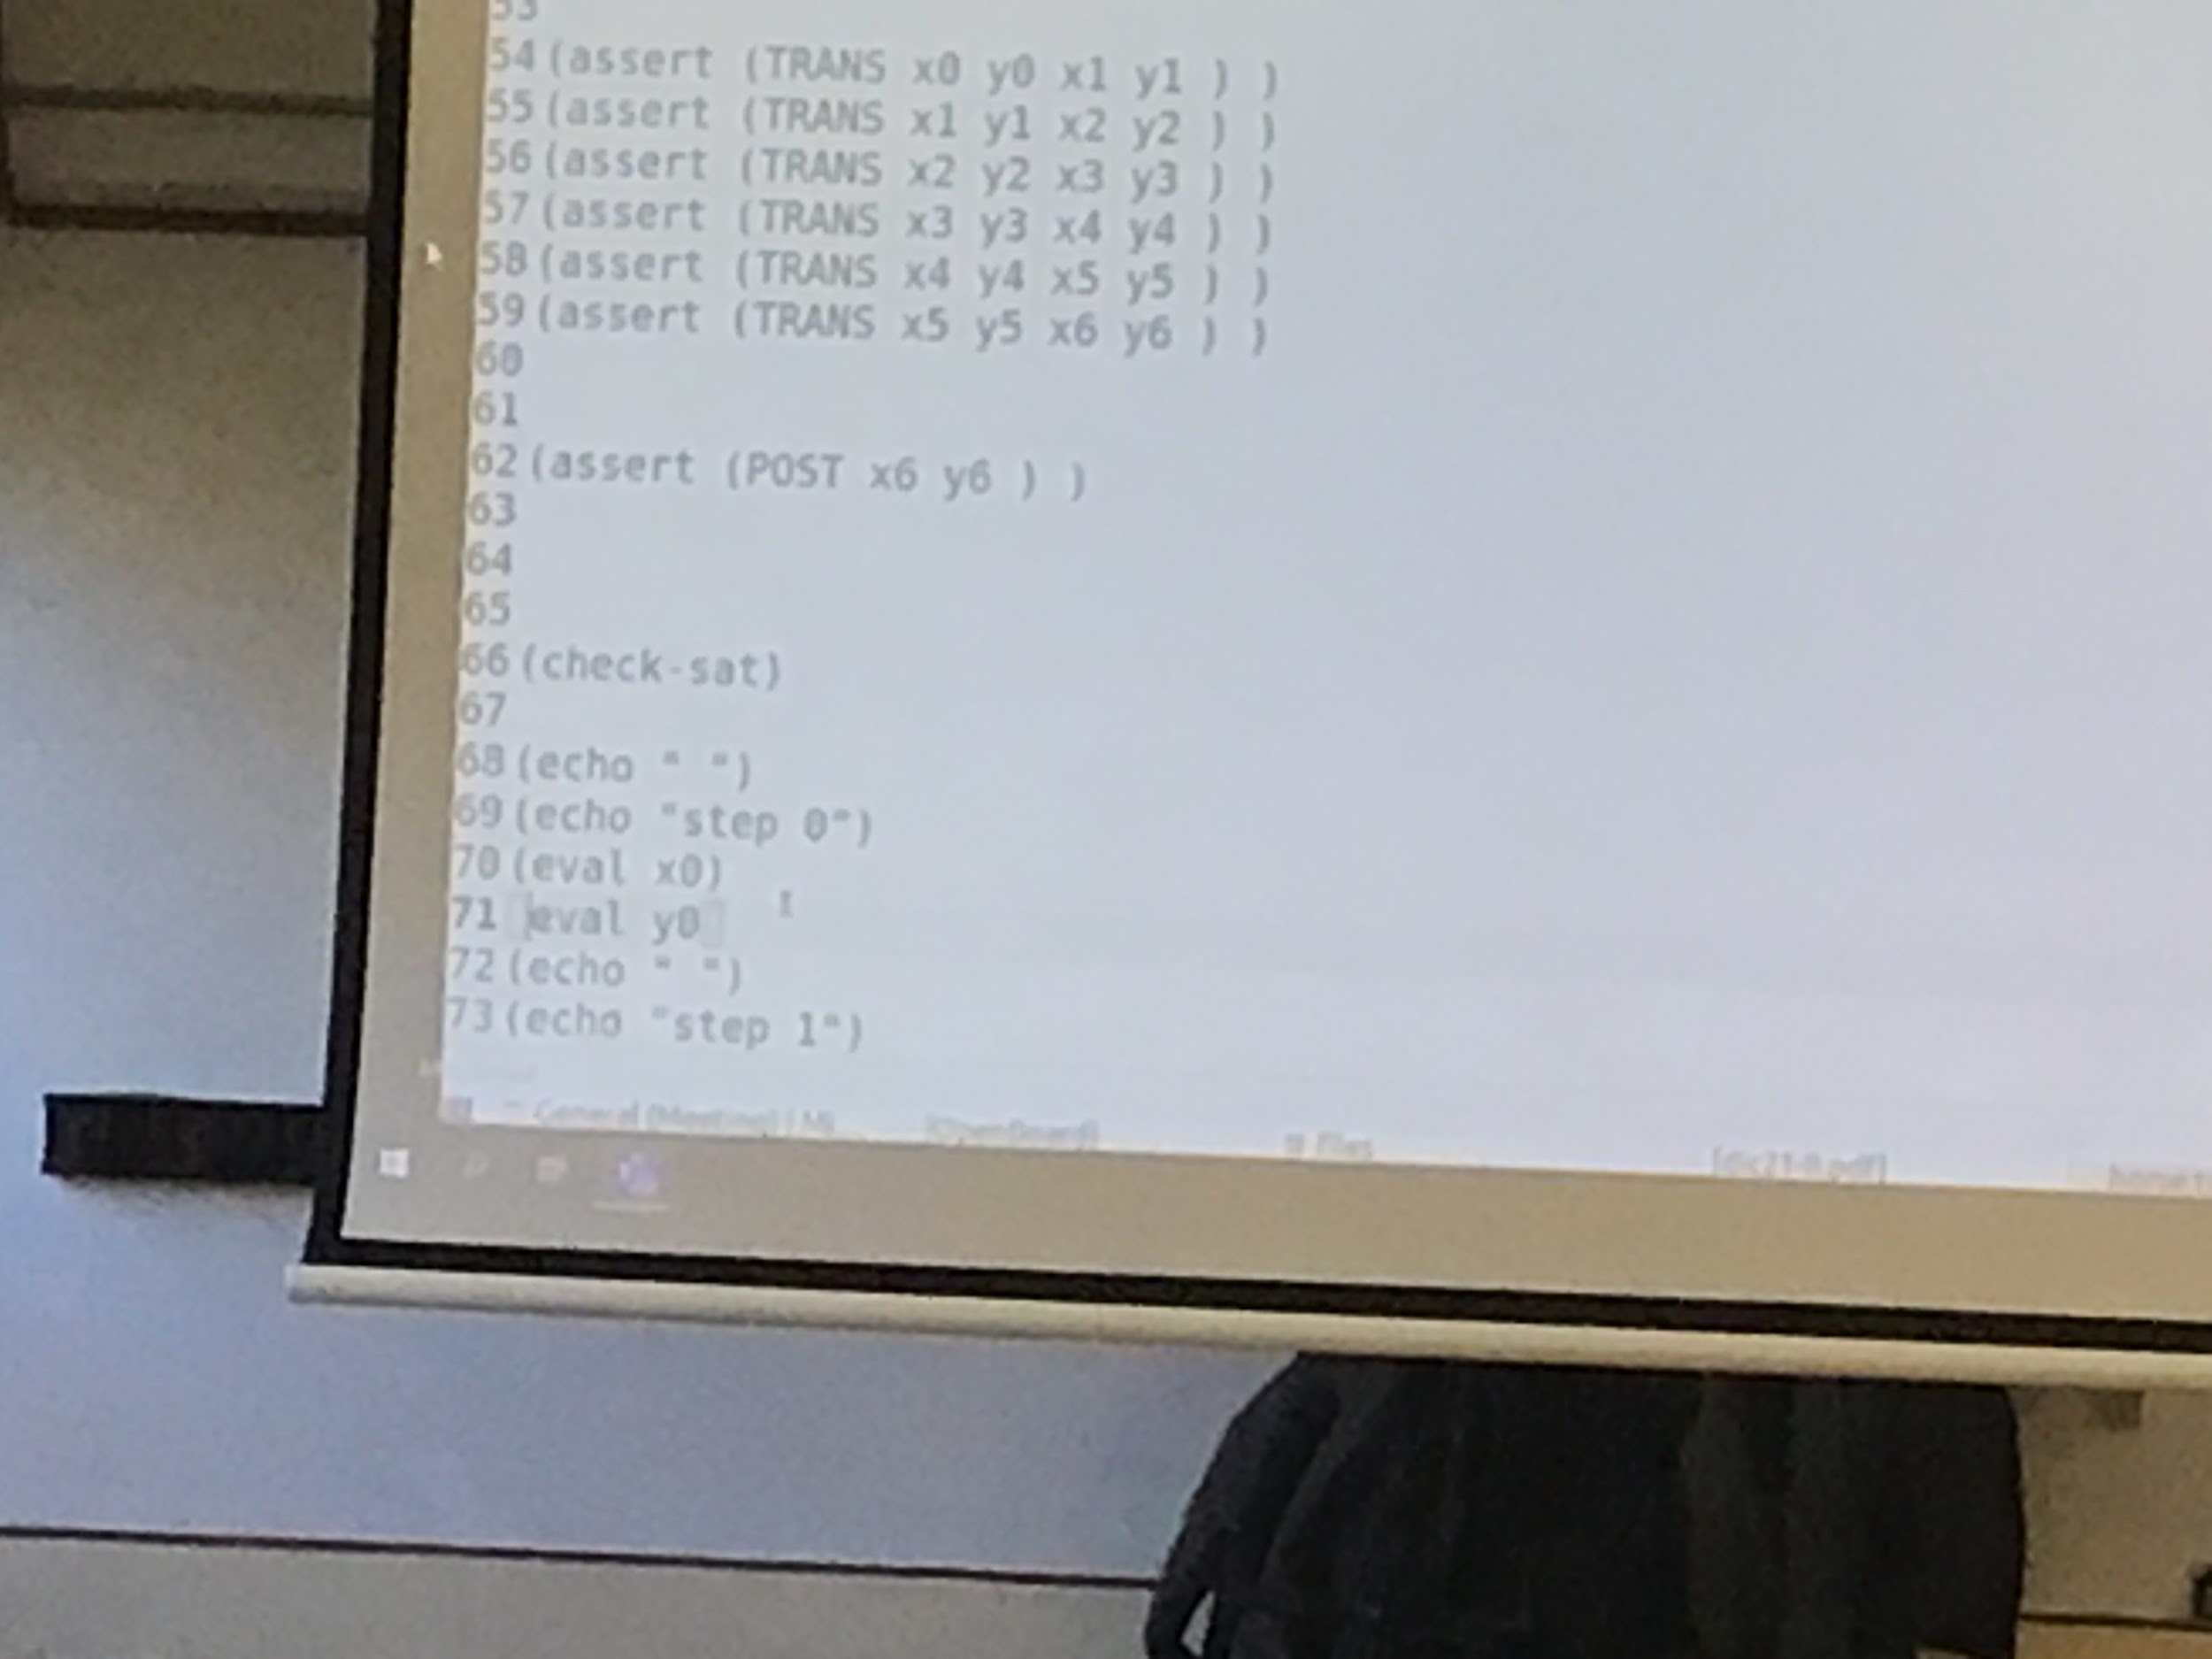

if then else

(ite <condition> value1 value2)

———

When two (or more) theories are present, we can work as follow: the theories should satisfying the conditions in the course note, in particular they must have only = as common symbol

First step is flattering

————-

Theory: set of axiom (standard in math logic)

a couple given by a signature and a class of structural (number with addition and subtraction) [SMT literature]

Linear integer arithmetic +,<, 0, -

+compeltare

+compeltare

Select(a,i) int→ int

A(i) (ray Int Int)

B=store(a,i,n)

B is the same function as a apart from the act that b(i) = n [a(o) could be something else]

Suppose you have a grid

1 2 3

4 5 6

7 8

Ca move the numbers

1 2 3

4 5

7 8 6

What to see if it possible to reach a certain model configuration, use an array, the change can be expressed

A(1) = 1

A(2) = 2

A(3) = 3

A(4) = 4

A(5) = 5

A(6) = 6

A(7) = 7

A(8) = 8

A(9)= 0

B =Store(store(A,9,6), 6,0)

Can write in a easy way the effect of the moves

Useful to implication of software

+capire triangolo